Ruth Roussard’s Turkey Gumbo
Made from Thanksgiving leftovers
Preparation time: 1 hour

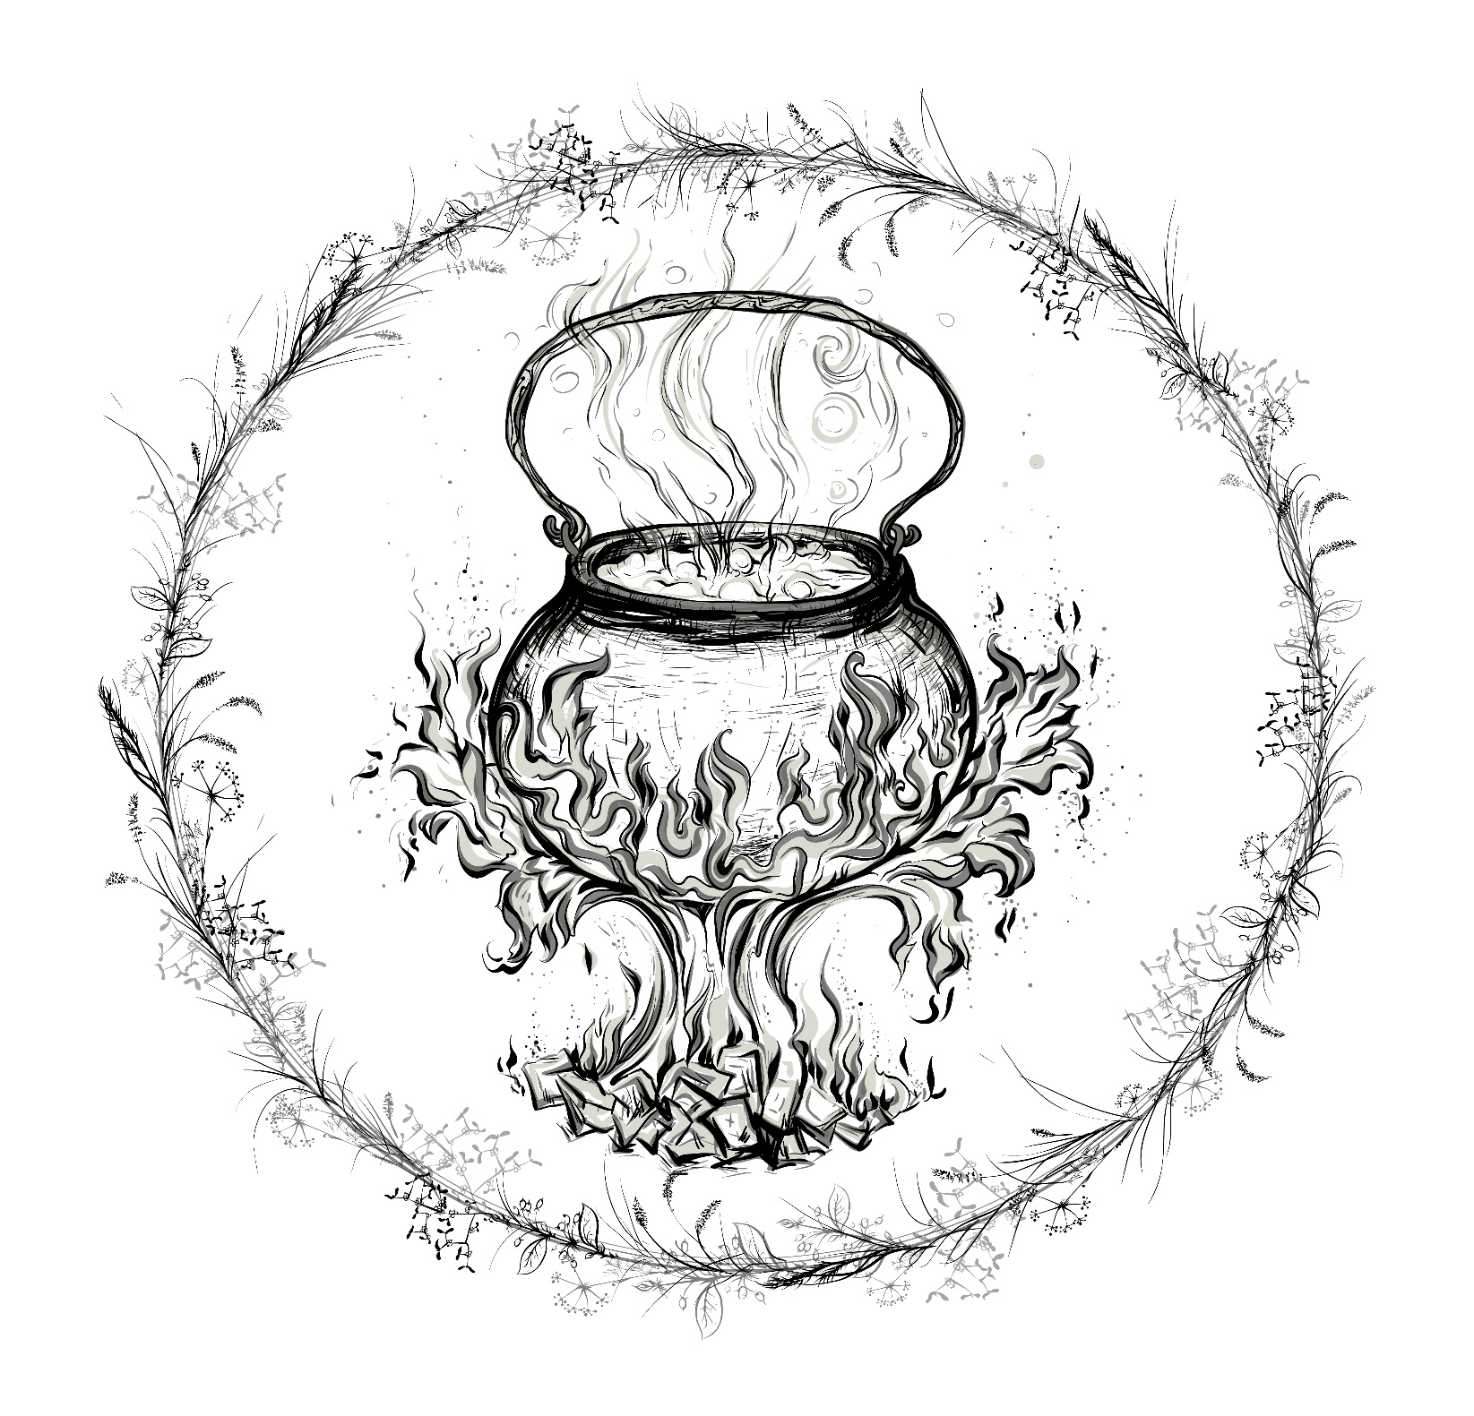

INGREDIENTS
- 4 stalks celery, chopped
- 3 small yellow onions, chopped
- 3 green onions, chopped
- 1 large orange bell pepper, seeded and chopped
- 1 small red bell pepper, seeded and chopped
- 8 cloves garlic, minced
- 3/4 cup canola oil
- 3 tablespoons olive oil
- 1 1/3 cups all-purpose flour
- 6 to 8 cups chicken stock or low-sodium chicken broth, as needed
- 2 cups vegetable stock
- 1 1/2 tablespoons chopped cilantro
- 1 1/2 tablespoons chopped parsley
- 2 tablespoons baby bok choy, chopped
- 1 to 2 teaspoons cayenne pepper (depending on your spice tolerance)
- 1/4 cup hot sauce, preferably Crystal
- 1/4 cup Worcestershire sauce
- 2 teaspoons kosher salt, as needed
- 1 1/4 teaspoons freshly ground black pepper, as needed
- 16 ounces andouille sausage, sliced into thin rounds
- 4 cups pulled cooked turkey meat, or chicken, or a mix of both, skin removed

Step one: In a food processor, combine 1/4 cup chopped celery, 1/4 cup chopped onion, and 1/4 cup chopped orange bell pepper. Process until smooth.

Step two: In an unheated, medium saucepan, combine 1/2 cup of the canola oil with the olive oil. Whisk to combine. Add the flour, and place over moderate heat. Cook, stirring slowly and constantly, until the roux is dark brown, 20 to 25 minutes. Add the puréed vegetables and stir to combine. Cover and reserve.

Step three: In a large pot, over moderate heat, warm the remaining 1/4 cup canola oil. Add the sausage and sauté, stirring occasionally, until browned on all sides. Approximately 7 minutes. Add the red bell pepper and remaining orange bell pepper. Sauté, stirring occasionally, until lightly soft and brown. Approximately 3 minutes. Add the garlic and onions, as well as the remaining celery. Sauté, stirring occasionally, until the onions are softened. Approximately 3 minutes. Add 6 cups of chicken stock, 2 cups of vegetable stock, then the cilantro, parsley, baby bok choy, cayenne pepper, hot sauce, Worcestershire sauce, and the reserved roux. Whisk as needed to dissolve the roux in the liquid.

Step four: Bring the gumbo to a boil, stirring frequently, then reduce the heat to low. Season with salt and pepper. Shimmer, while stirring frequently, until mixture thickens to the consistency of a chowder. Approximately 15 minutes. Add the meat and simmer, stirring occasionally, until the meat is thoroughly heated. About 5 minutes.

Serve warm and enjoy!

